Handle Calendar in Selenium WebDriver

First screenshot, Handle calendar by splitting and storing date into array..

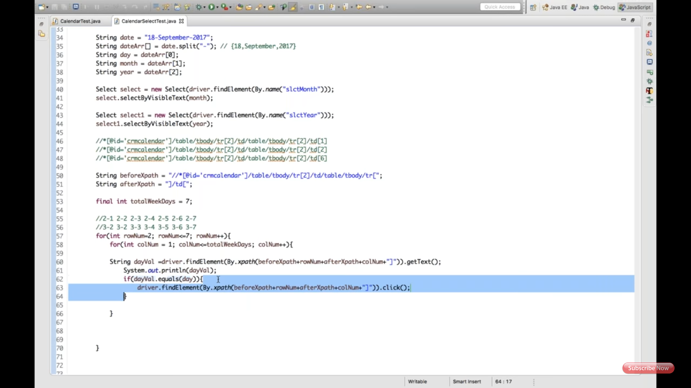

Second screenshot showing how break and flag used to break the loop.(outer loop should not terminate with clicking on the date.)

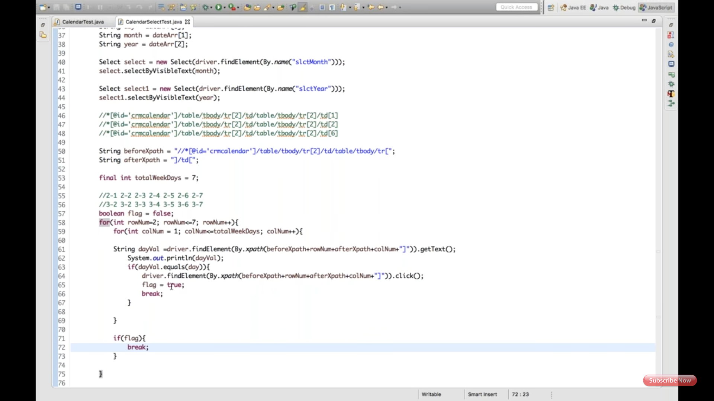

Third screenshot explains try and catch for the wrong date.

